First off : we need to try another font, please switch it to **“merriweather”**. AND pleaaaase, make the time for switching between pictures on the slide show a bit longer.

I hope this font looks good, otherwise I will think of another.

ALSO please change the normal text color from blue to black.

Next:

We need to make the whatsapp icon smaller and place it a bit above the “Up arrow” on the bottom right of the page.

So for the text edit for the slideshow pics: font size of the text below the main heading needs to be about 3-4 pts lower and bold.

**PIC 1 :**

**ELDERLY CARE**

**Our wide range of carefully curated specialized services provide a *360 degree solution* for Elderly Care in DEHRADUN.**

**PIC 2:**

**PARENT CARE**

**We help you *bridge the gap* of distance between you and your parents with our personalized Parent Care plans.**

**PIC 3:**

**PATIENT CARE**

**Our specialized services help you with all your *Out & In-Home* Patient Care needs.**

**PIC 4:**

**DISABILITY CARE**

**Our Disability Care plans cater to *all age groups* and are personalized to meet all your unique demands.**

**PIC 5:**

**MOTHER & CHILD CARE**

**We create *personalized plans* based on your requirements to assist you in your Mother & Child Care needs.**

**PIC 6:**

**EMOTIONAL WELLNESS**

**We offer specialized services to all age groups that focus on managing *Mental Health & Emotional Wellbeing.***

**Lets update this part**



**Put the 6 buttons mentioned in the first document. Also on the donate button, change it to book now and leave the heart sign there. Also you can remove the dark mode sign.**

**Moving on: attaching the LOGO PNG and the other landscape photo in this email. So add that.**

**Lets make the Our Values, our mission Our vision, To ALL CAPS.**

**NOT happy with this part: Its too occupied…..**

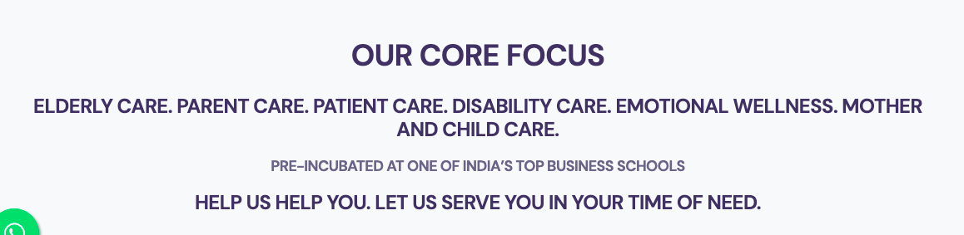

**Replace Our Core Focus to SPECIAL CARE SERVICES, please space out all these lines properly.**

**The next line with elderly care etc, change it from a single to a double line, and make it in a way that the size is bigger than the last line with HELP US.**

**Also need to play with 2 color combinations in this one for each care listed. Space out the lines well.**

**Like: something like this**

**OUR SPECIAL CARE SERVICES**

**ELDERLY CARE. PARENT CARE. PATIENT CARE.**

**DISABILITY CARE. MOTHER & CHILD CARE. EMOTIONAL WELLNESS**

**We are Pre-incubated at one of India’s TOP B-SCHOOLS**

**HELP US HELP YOU.**

**We are here to serve you in Your Time Of Need**

**CHANGE: the Request button text to “ENQUIRE NOW”**

**CHANGE THE OUR PROMISE to our customers TO JUST “OUR VALUES”**

**And ADD The 6 headings I sent you**

1. **Quality. Trust. Reliability.**

**We know when it comes to special care for you and your loved ones; it’s not about the price or the quantity but the Trustworthiness, the Quality and the Reliability of the services you receive. We go The EXTRA Mile.**

1. **Thoroughly Verified. Well Trained Staff.**

**All our staff goes through an intensive background check. They are well trained in their specific fields of service and follow a professional code of conduct, to provide you with the best experience.**

1. **Comfortable On The Pocket.**

**We understand that sometimes the cost can be a constraint in making a final decision, therefore we try to help you with a personalized plan that will fit well within your budget, and without any compromise on quality of the services we offer.**

1. **We Can Relate.**

**We’re on this journey with you. Our Founders themselves have lived abroad and/or in cities away from their parents and understand that feeling of responsibility. So they are on a mission to efficiently tackle this issue.**

1. **We Value Your Trust.**

**We know that trusting another with your needs isn’t easy, that is why we go through a thorough process of first understanding our customers and their specific needs before deciding on a suitable service plan and its implementation.**

1. **We Give Back.**

**Everytime you allow us to serve you, we play the role of a good samaritan by dedicating a part of our earnings to support the less fortunate elderly population.**

**MOST HAVE THE SAME AMT OF TEXT EXCEPT LAST point. See if you can make this much fit, even if its smaller size , lets see how it looks.**

**JOBS PART GIVE THIS TITLE: WORK WITH US**

**ALso for the pictures please change text as follows: in all CAPS**

**Pic 1 : CAREGIVERS & NURSES**

**PIC 2: WELLNESS COMPANIONS**

**PIC3: CREATIVITY TEACHERS**

**PIC4: SUPERVISORS**

**The OUR MOTTO PART, make the our motto underlined, also the next like needs to be in italics and the last line is too small so make it a bit bigger and in all caps.**

**The Last EMAIL part please change text to :**

**To keep updated with our activities and future launches, provide us with your email.**

**We promise we won’t spam you.**

**Hope this much can get done so that the homepage is ready by tomorrow.**

**The rest of the content about the services etc, will follow.**

**Thank you. Find the images separately in the email.**